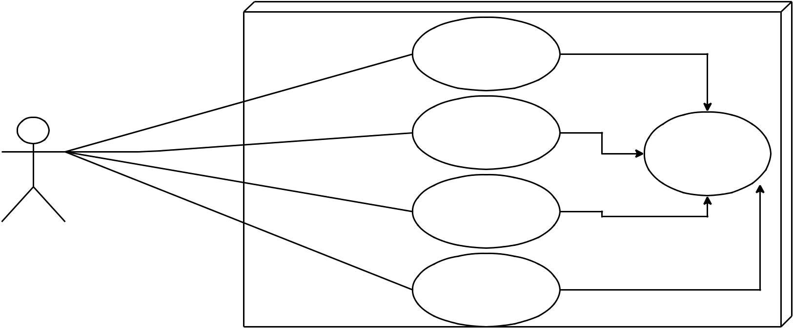
Library System

Add New Item

Delete Item

Save

Sort Items

User

Search Item

